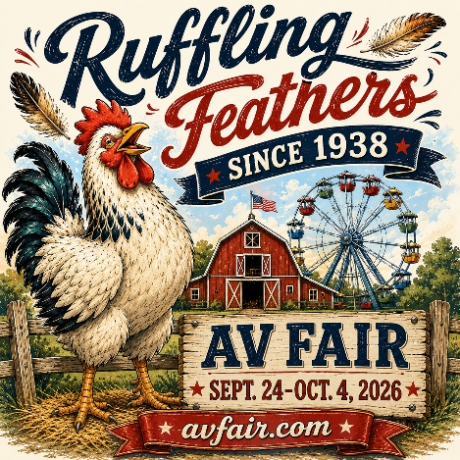
Dress & Decorate Contest

JUDGING DATE: Tuesday, September 22nd between 9 am and 5 pm

WINNERS Announced:
Wednesday, September 23rd on AV Fair Social Media Accounts

Decorations MUST stay up through the END OF Fair, October 4th!

“Ruffling Feathers Since 1938”
Theme art to use for decorations at
www.avfair.com

Judging based on:
- Creativity and Originality
(FAIR 2026 theme & office décor)
- Employee Participation

GRAND Prize wins:
- Monster Truck Tickets For Staff (up to 20).

1st, 2nd and 3rd place awarded – winners receive Ribbons and admission tickets for their staff! (up to 20).

All businesses judged in the contest will be listed on our website – the deadline to enter is September 18th! Enter by email at jcloud@avfair.com.

For more information, call Phyllis at 661-917-5250 or Anna at 661-406-8380

For ALL Fair 2026 information and to buy tickets, go to www.avfair.com
---------------------------------------------------------------------------------------------------------------------
2026 A.V. Fair Business Dress & Decorate Contest Entry Form

Contact Name: _________________________________________________________________

Business Name: _______________________________

Address:_______________________________________________________Zip_____________

Phone: ___________________Fax: _________________Email___________________________

